A/B TESTING ANALYSIS

Experiment overview:

A/B TESTING ANALYSIS

**INTRODUCTION**: 

A/B testing also known as split testing, is a method used in marketing and product development to compare two versions of a webpage, email campaign, or product to determine which one performs better. The goal is to make data-driven decisions and optimize your offerings for improved user engagement, conservation, or other key performance indicators (KPIs).

TEAM MEMBERS:

CH .SRINU(TA)

CH .PREM KUMAR

Y.RAM SAI

M.RAGHAVENDRA

V.KRISHNA PRASAD

G.BHANU RAJESH

EXPERIMENT DESCRIPTION:

OBJECTIVE:

A/B test helps to determine which of two different assets performs better and also optimize marketing campaigns, improve UI/UX, and increase conversions There are multiple versions of A/B tests for testing individual pages, multiple variables, and entire workflows and funnels.

Hypothesis:

A/B testing analysis is used to compare two versions of e-commerce i.e., old and new versions. After the testing of analysis, got a expected result.

EXPERIMENT SETUP:

Data Resource:

The data was collected from Kaggle dataset which is widely used for e-commerce, mail campaign and more over products to determine which one is better.

**DATA EXPLORATION:**

In the data exploration phase, we can know which web page is mostly used and most effective We generate the effective web page using mean, t-test. We utilize data visualizations, including bar plot and boxplots.

LIBRARIES:

* NUMPY:

To perform a wide variety of mathematical operations on arrays.

* PANDAS:

For data analysis & associated manipulation of tabular data in data frames.

* MATPLOTLIB:

For creating static, animated and interactive visualizations.

* SKLEARN:

To interoperate with the python numerical and scientific libraries.

ALGORITHM:

Logistic Regression: It is a statistical method used for binary classification, where the goal is to predict a binary outcome based on one or more predictor variables. This method is widely used in machine learning and statistics tasks.

**Logistic Regression Implementation**

* Data pre-processing step
* Hypothesis Testing
* Predicting the test result
* Test accuracy of the result (creation of confusion matrix)
* Visualizing the test set result

Visualization:

Visualization plays a crucial role in A/B Testing analysis helping to communicate results and insights effectively.

The Visualizations used in our project is:

* Conversion Rate Comparison
* Box Plots
* Comparison Tables

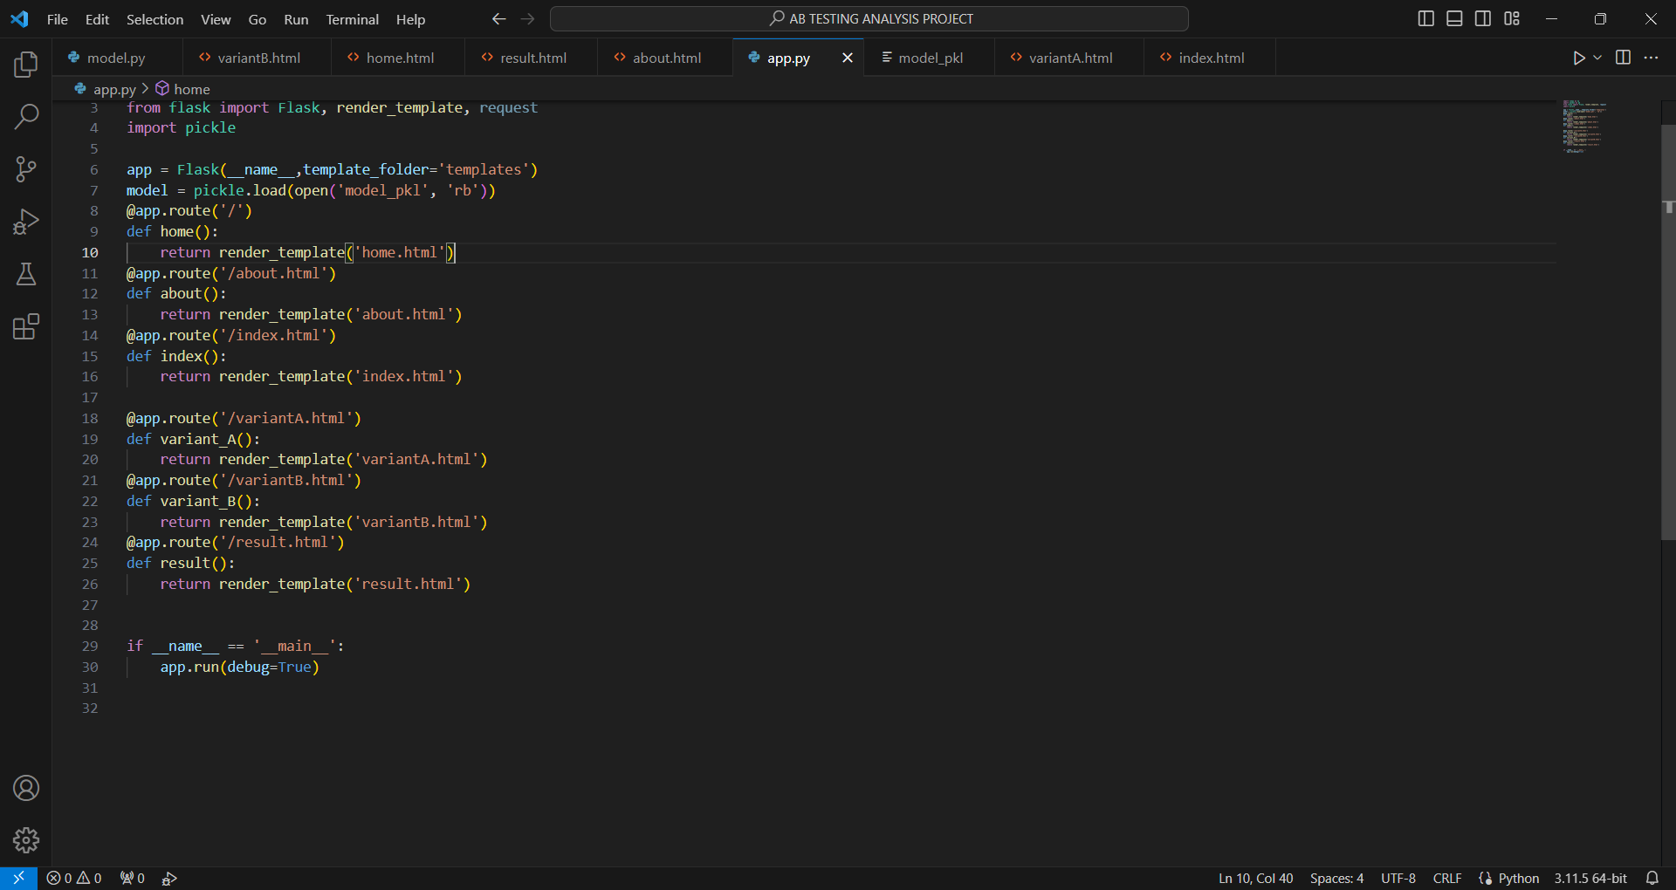

Results:

Test Statistic:

The probability under the assumption of effect or has difference of obtaining a result equal to or more extreme than what was actually observed. The P stands for probability and measures how likely it is that any observed difference between groups is due to chance.

Control Group Mean: 99.32114938764708

Test Group Mean: 110.20425410474245

T-statistic: -16.586295300058485

P-value: 5.502491398078317e-58

The difference between the control group and test group is statistically significant.

Accuracy: 0.615

Classification Report:

precision recall f1-score support

0.0 0.61 0.64 0.62 199

1.0 0.62 0.59 0.61 201

accuracy 0.61 400

macro average: 0.62 0.62 0.61 400

weighted average: 0.62 0.61 0.61 400

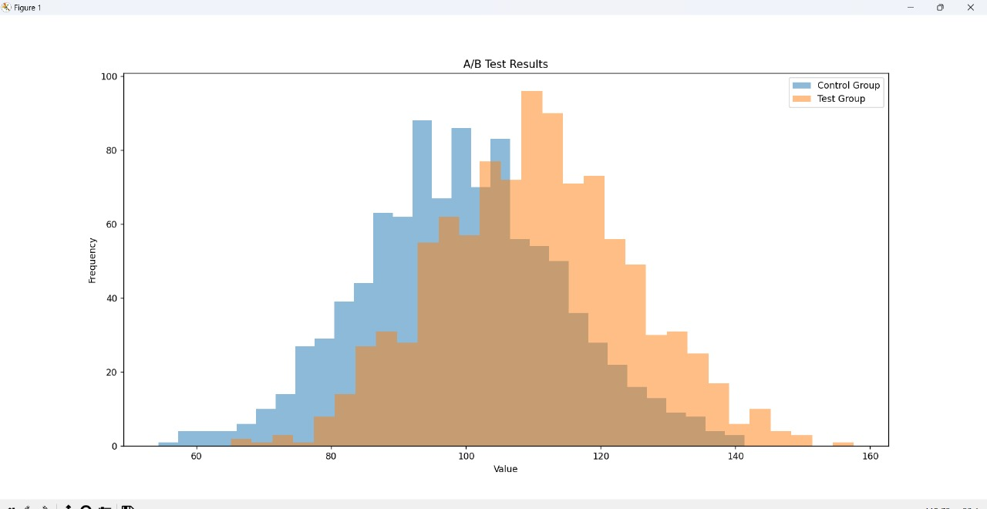

Conclusion:

A/B testing analysis is a powerful tool for data-driven decision-making, enabling us to optimize our digital assets, marketing campaigns, and products while ensuring that our strategies align with user preferences and objectives. It underscores our commitment to delivering the best possible experience to our users and driving growth and success for our organization.